Holy NOTES OF THE BYZANTINE EMPIRE
The Big Idea
The Roman Empire split into two parts,
and the eastern Roman Empire prospered
for hundreds of years after the western empire fell.
Main Ideas
- Eastern emperors ruled from Constantinople and tried but failed to reunite the whole Roman Empire.
- The people of the eastern empire created a new society that was very different from society in the west.
- Byzantine Christianity was different from religion in the west.
MAIN IDEA 1
- _________________________________________ was built on the site of the ancient city of Byzantium and became the center of ________________ ____________________________
- _____________________________ ruled from 527 to 565.
- His army conquered Italy and more land around the Mediterranean.
- Justinian’s enemies tried to overthrow him in 532.
  - Riots in the streets almost made Justinian leave Constantinople.
  - His wife, Theodora, helped him find a way to end the riots and stay in the city.
- Following invasions by _____________, _________________, and ______________________, later emperors lost all the land Justinian had gained.
- Constantinople was captured by __________________________________ in 1453, ending the eastern Roman Empire.
Main Idea 2
- After the death of Justinian, ________________________________________ _______________________________________________________.
- Gradually, the empire lost its ties to the old Roman Empire, and a new society developed.
  - Byzantine Empire is what modern historians call the society that developed in the eastern Roman Empire after the _______ _________________________.

Influence | Language | Philosophy | Government

MAIN IDEA 3
Similarities Between East and West
- Most people who lived in the Byzantine Empire were ________________.
- Byzantine artists created beautiful works of religious art, such as ______________________, pictures made with pieces of colored stone or glass.
- They also built magnificent churches, such as __________________.
Differences Caused Division
WEST | EAST
1.  2. | 1.  2.

- The Christian Church officially split in the 1000s.
- Eastern Christians formed the ________________________________.
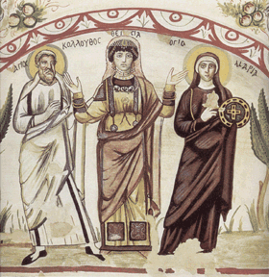

The Roman Empire vs. The Byzantine Empire
